**Database Systems Quiz 8**

**U00839259 (syrrmlla)**

1. **Check out the Cypher queries in the companygraphdb.txt file and draw its graph diagram (directed graph with relationships). The companygraphdb.txt file can be found in the related module on canvas. You can draw it on a blank paper, and take a photo with your smartphone and copy/paste it in your quiz answer form.**

**2.Using the queries in the companygraphdb.txt file, generate a new graph database called “companygraphdb” in Neo4j. After you generate the new database, include a screenshot of the web user interface (**[**http://localhost:7474/browser/**](http://localhost:7474/browser/)**) showing that your company graph database is generated.**

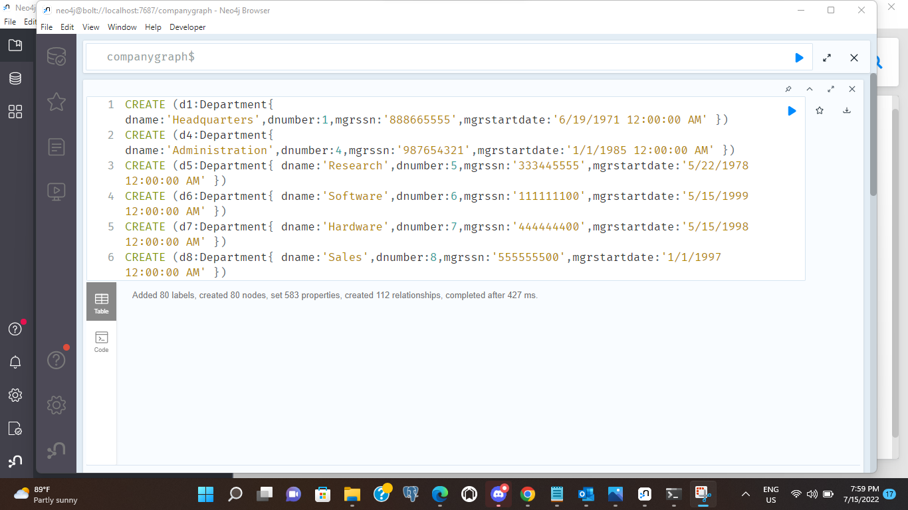

**3.Write Cypher queries for the following use cases (do not put any screenshots, only Cypher queries):**

1. **Retrieve all the employees (nodes).**

Match(e:Employee)return e

1. **List the first name, last name and salary of all employees.**

Match (e:Employee) return e.fname,e.lname,e.salary

1. **Retrieve all employees (nodes) who work for the 'Sales' department.**

MATCH (e:Employee)-[WORKS_FOR]->(d:Department{dname:'Sales'}) RETURN distinct e,d

1. **Retrieve all employees (nodes) who work for the ‘Sales’, departments (nodes) and their relationship.**

Match(emp:Employee)-[n:WORKS_FOR]->(p:Department) where p.dname = 'Sales' with emp Match (emp)-[n1]->(pn:Department) return emp,n1,pn

1. **List all the department names which are located in Houston**.

MATCH (d:Department)-[r:LOCATED_IN]->(l:Location) where l.dlocation='Houston' RETURN distinct d.dname

1. **List all the first name and last name of employees, the project names that they have been working on, and the amount of time they spent for those projects.**

Match(e:Employee)-[r:WORKS_ON]->(p:Project)return e.ssn,e.fname,e.lname,p.pname,r.hours

1. **Get the total number of the projects that each employee has been working on.**

MATCH (e:Employee)-[r:WORKS_ON]->(p:Project) RETURN e.fname, e.ssn ,count(distinct p.pnumber)